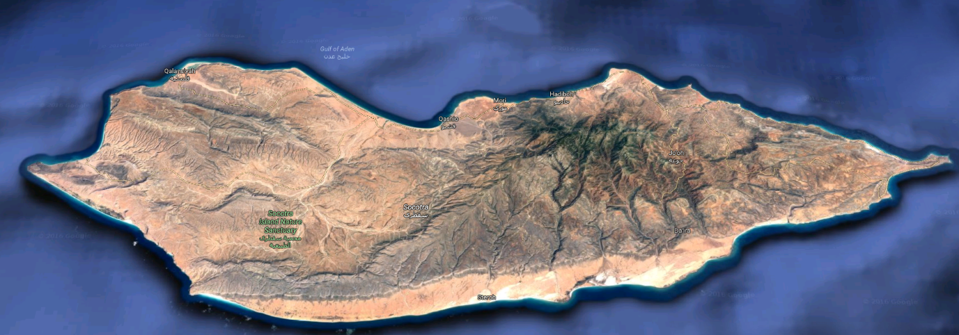**Island research and ideas**

This is the island of Socotra. It is 132Km (82mi) in length and 49.7Km (30.9mi) wide. It has a population of 44,000 people. It is also 240Km (150mi) east of the horn of Africa.

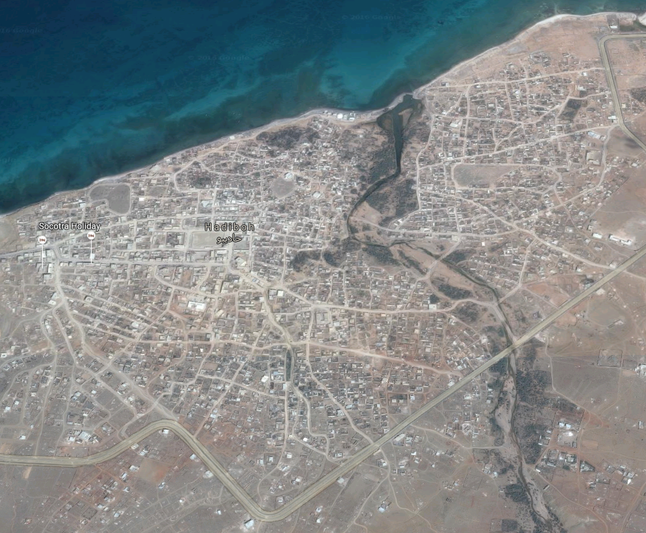

This city appeals to be the main capital on the island, it is called Hadiboh.

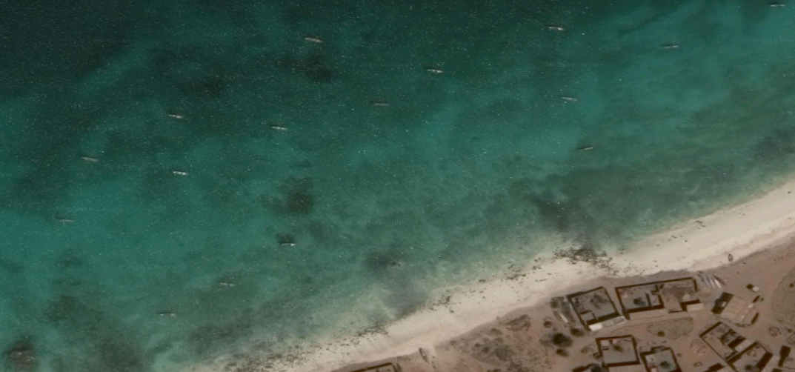

On the west side of the island there appears to be a small village that fishes for food and maybe trade.

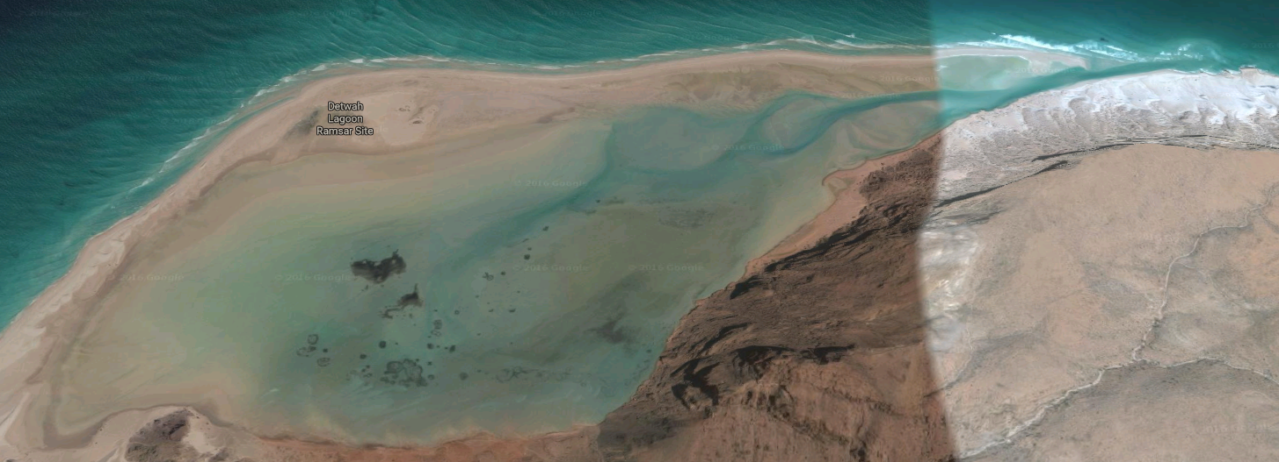

North West of the island there is a lagoon, which could be a good spot to build marine research centre, and study live under water around the island.

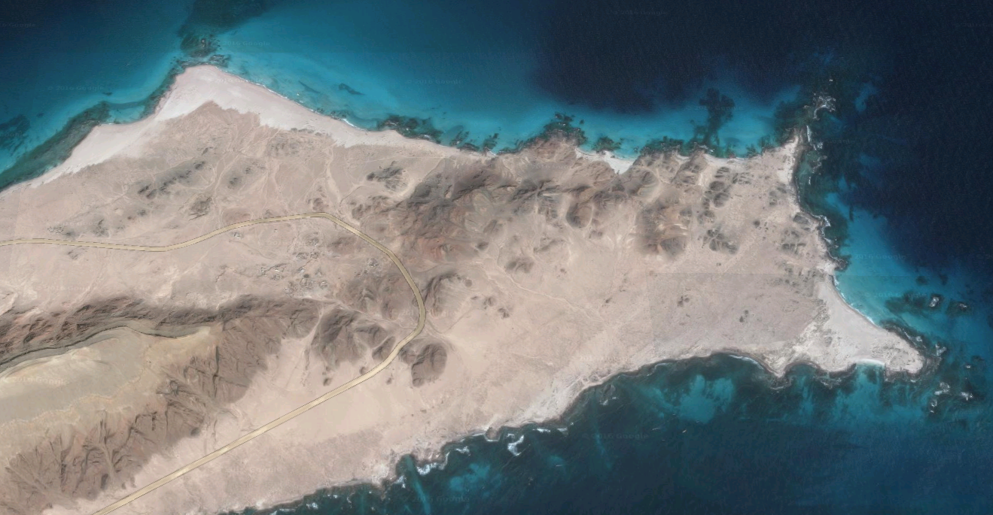On the east side of Socotra, there is this small area with deep water. This would be a good area for a port for trade and tourists, but the bad side of it, is that it is the other side of the island, which means its farer away from the horn of Africa.

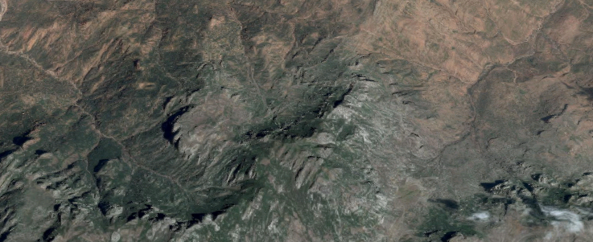

South of the Hadiboh, there is the main mountain, this spot is between the peak of the mountain and the city. This area would be good for a church/temple, as it’s a good walk from the noise of the city, but not too steep that it’s hard for people to get to it.

**Logo, symbol and flags**



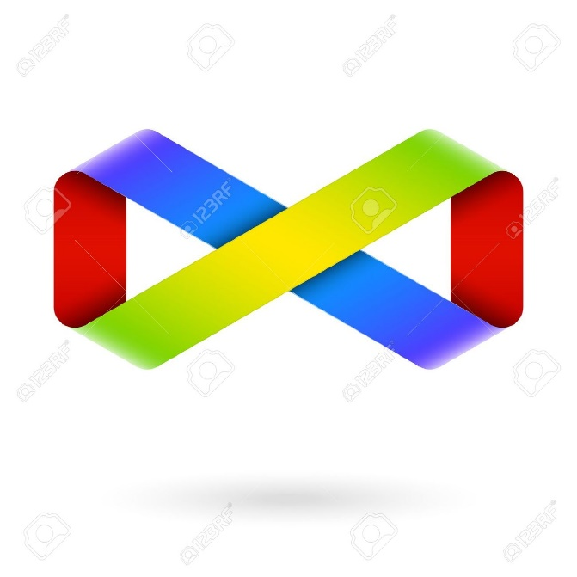

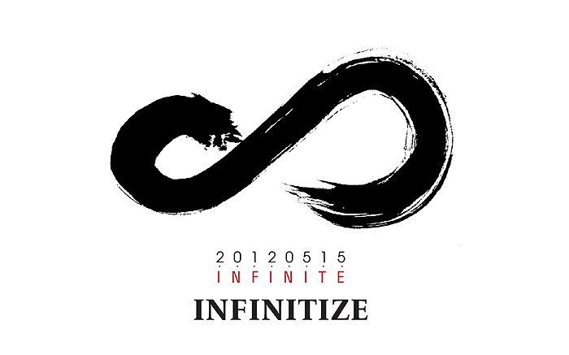

­

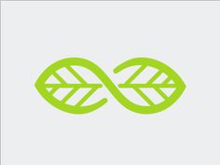

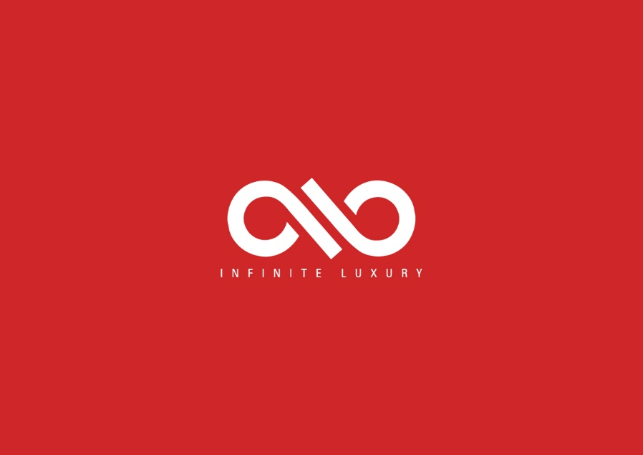

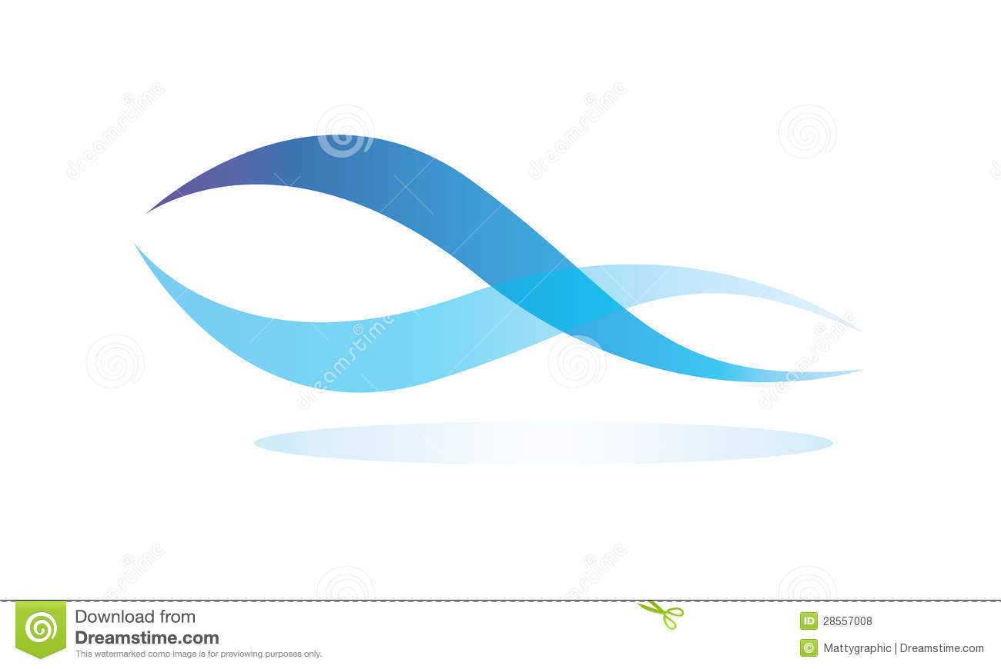

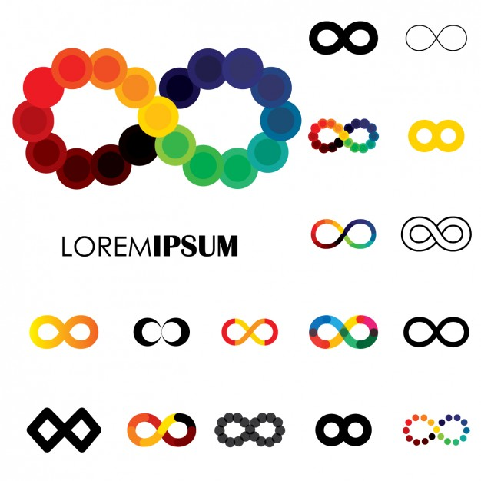

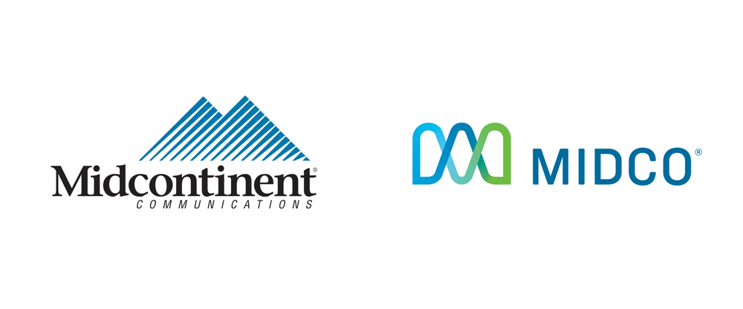



**Flag designs**

The idea behind the flag/symbol design, is that the mountain represents the land we walk on and mountains get higher and higher, which we try to follow. And the infinity Part is everything, so it’s that we can always get better, do better and try harder.

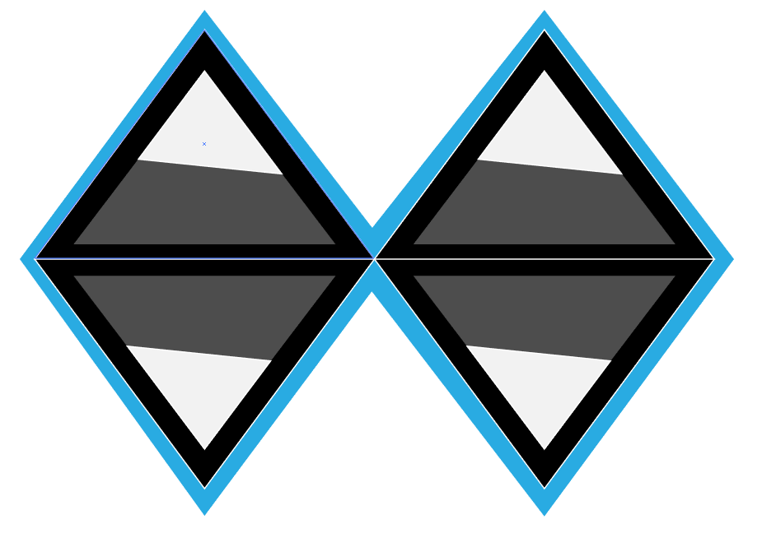

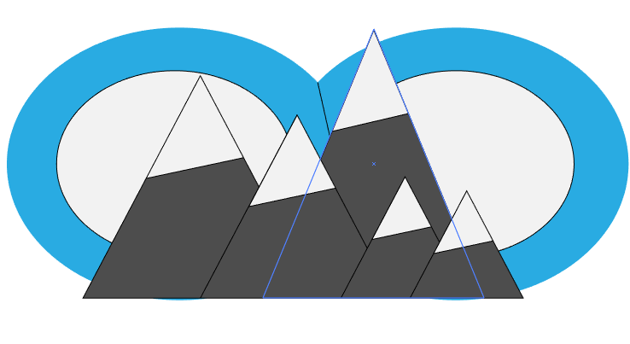

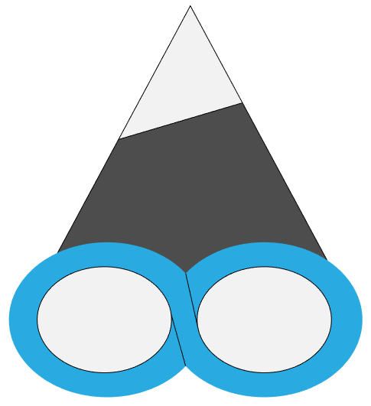

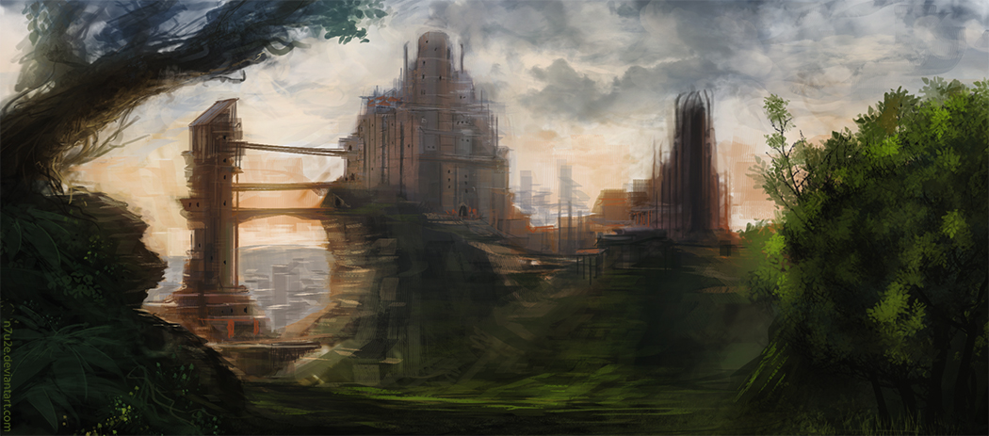**Urban Architecture**

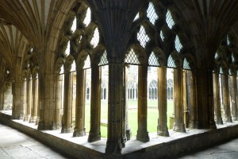In this section, I’m looking at different architecture, mostly around churches and cathedrals. As the book the alchemist, has a holy, omens, god theme throughout the book. I’m looking at real life buildings from around the world and fantasy buildings and churches.

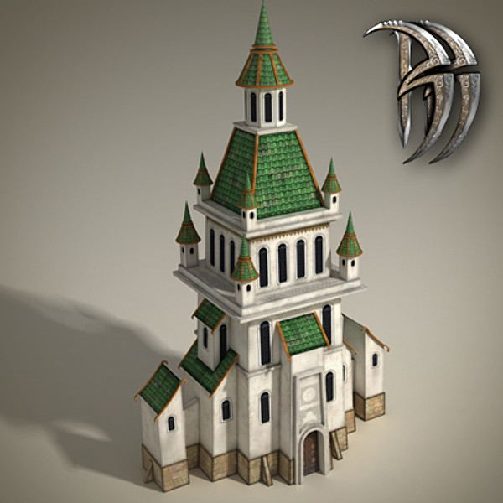

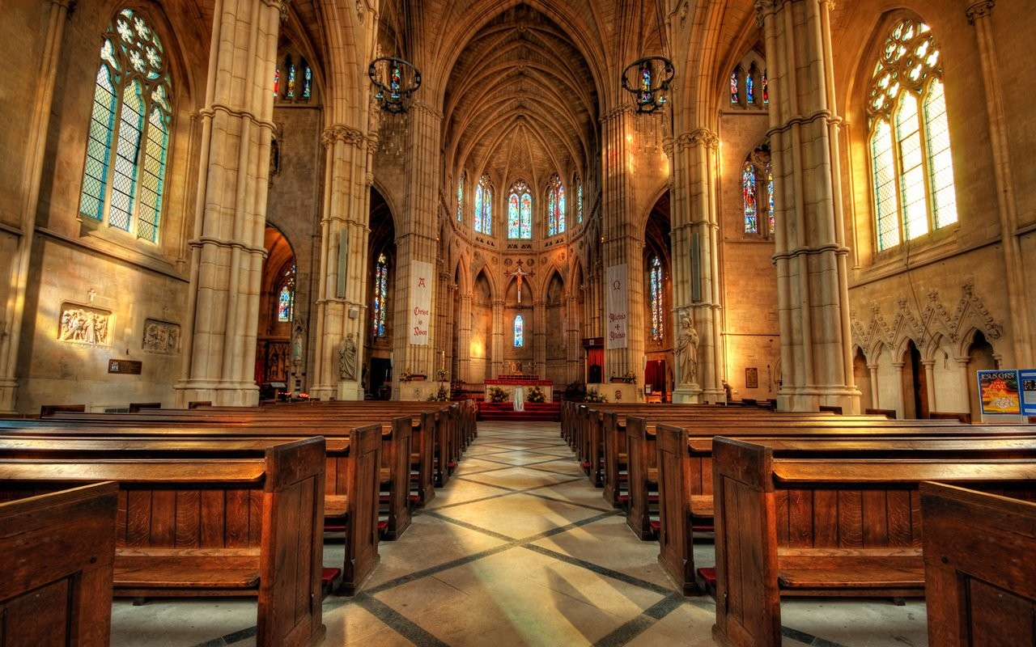

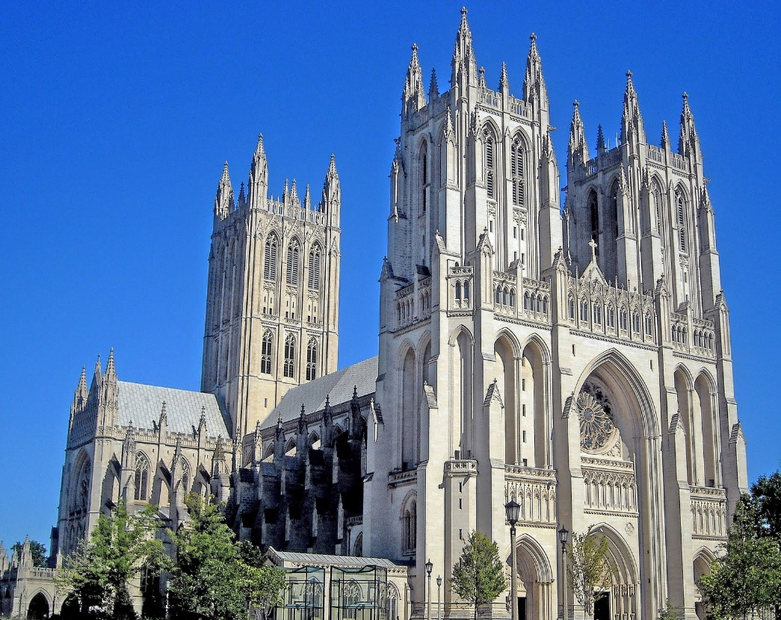

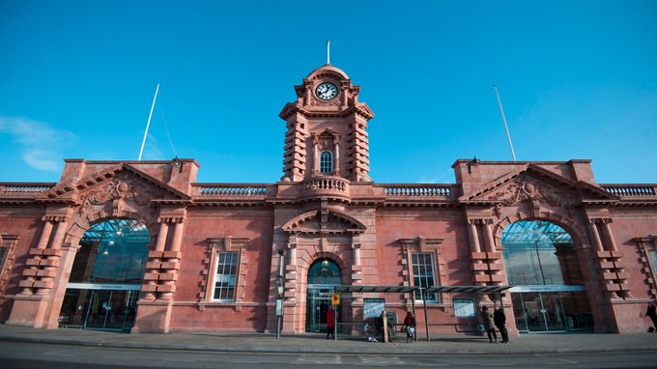

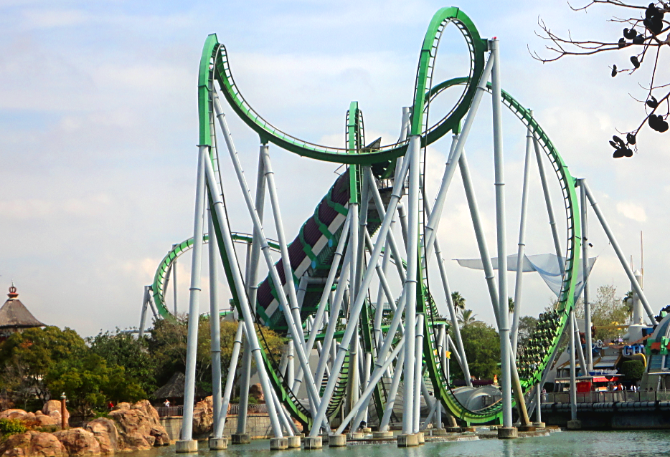The reason for the roller coaster in the urban architecture, is that roller coasters have to flow smoothly, so on the design of the building, I would like the buildings details to flow smoothly together.

**Rural architecture**

In the rural architecture, the island has lots cliffs and beaches.

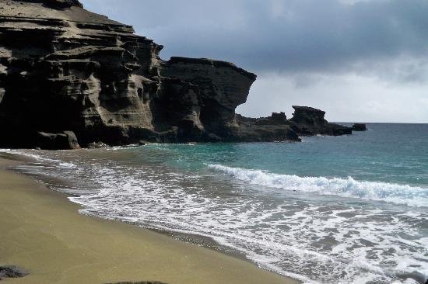

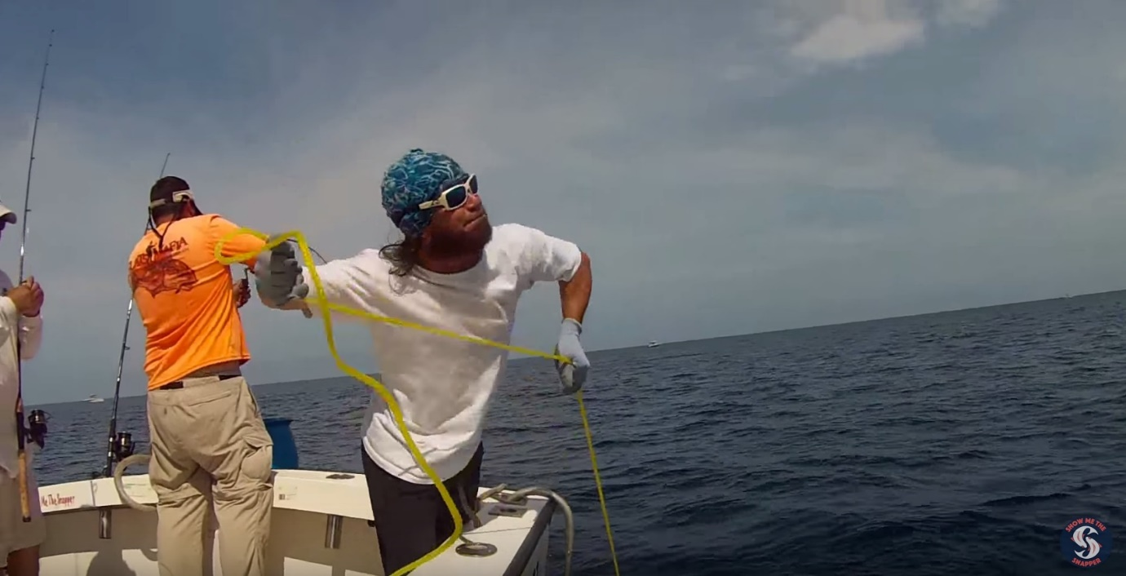For food, the people can fish, mostly with hand lines, catching fish, but the problem with that, is that you might catch a shark, or that your line gets court on something and that you have to go in the water. Also hand lining can be a tiring task, if there’s a big fish on the other side that you have to fight.

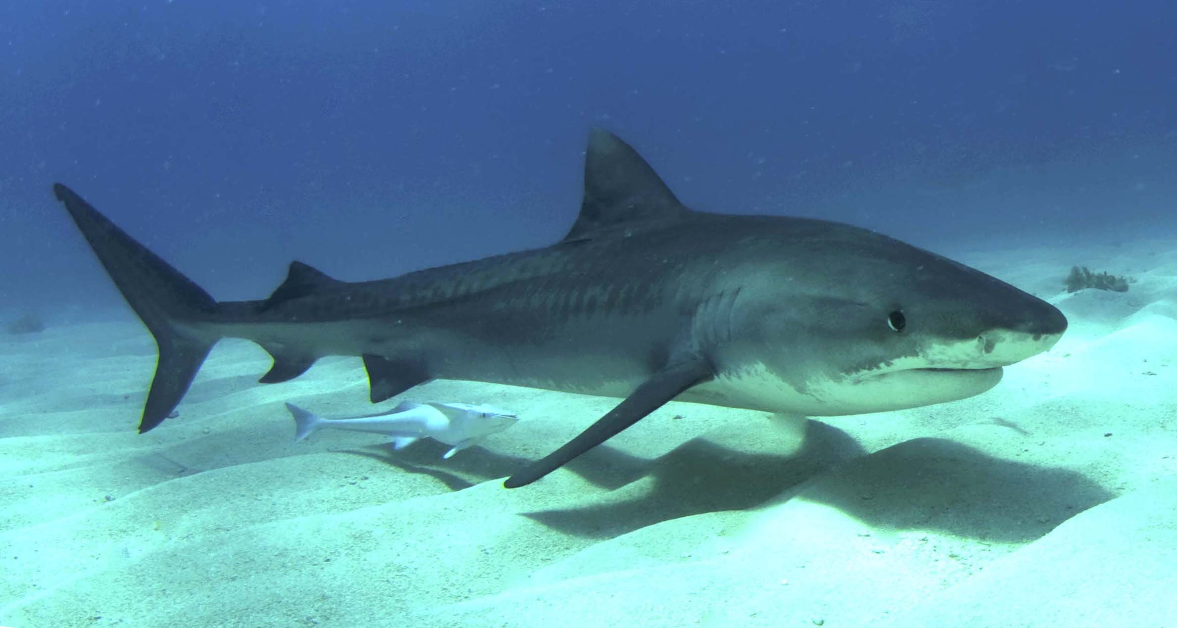

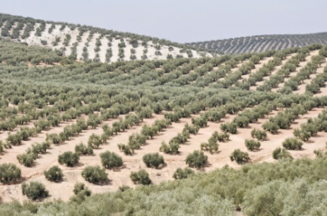for farming, the island has many rivers that you can use to water the plants, and due to the high temperatures on the island, the plants should grow fast as long as they have water.

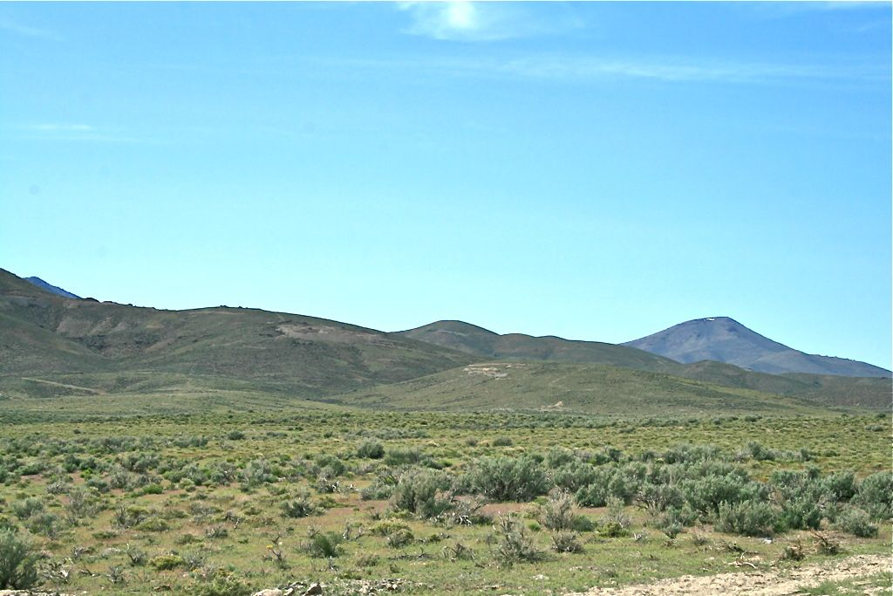With the book having a holy, god, omen theme throughout the book, the island will have several temples/churches on it, but instead of them being close to the villages and cities, they will be up the mountain area, towards the gods.

**Constitution preamble**

We the people of Socotra build towards a better future, no violence or firearms will be set upon their ground. Any form of violence is punishable up to a sentence of death. The judgement will come from the community. The island is the community, everyone is to help everyone. Freedom of speech is permitted, freedom of the heart and travel is welcomed. The community is the government, no leading person or party makes final decisions. Upon entrance, on to our ground, must give up everything from past life. All money, technology, clothes, etc. The island and the ocean are our home, so we take care of them, no matter what, anyone court not caring, is punished by the community.

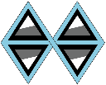

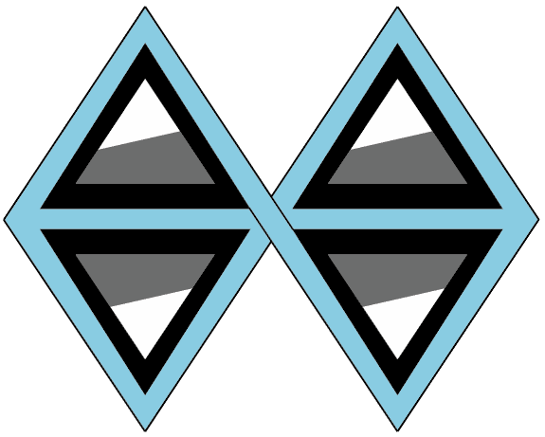**Final flag design**

**Poster design**

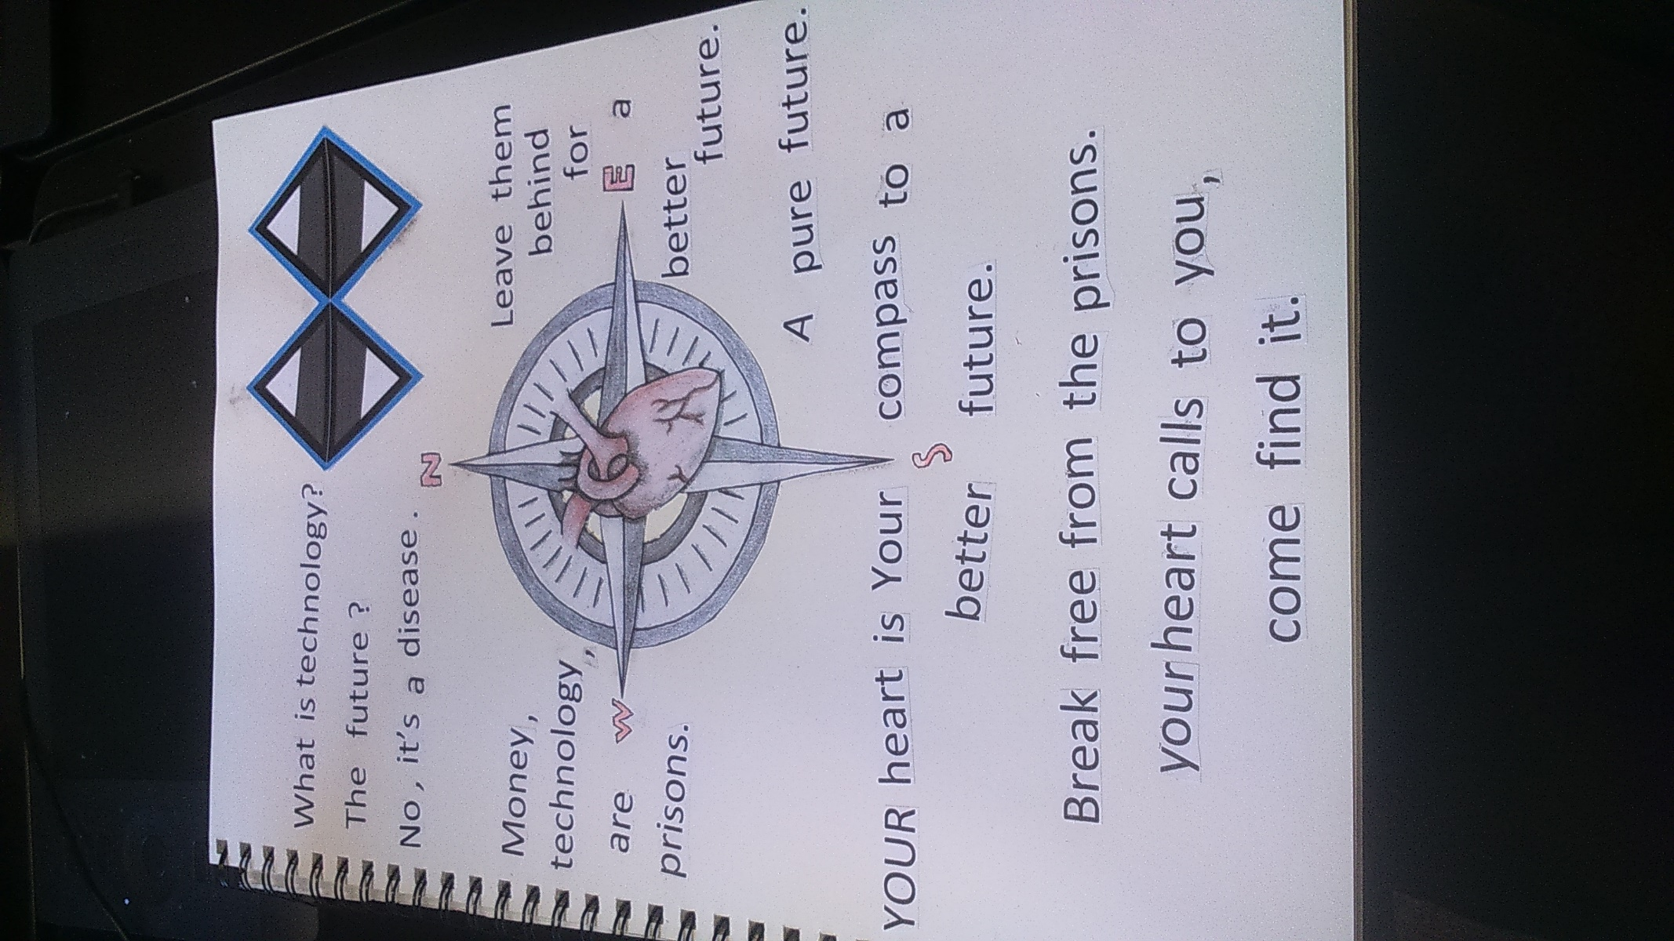

These are some rough renders of my flag design, on a flag in the wind.

